Bank Log-Loss & Cost (Retail PD Scorecards)
C1_W3 Lab04–05 adapted to underwriting · short name: Bank_LogLoss_Cost

Problem Statement
A regional bank must compare two frozen PD scorecards on the same retail files. Squared error on a sigmoid PD is not a soup bowl, so it is the wrong objective. The bank also must not confuse logistic loss (how surprised the PD is) with expected credit loss (PD × LGD × EAD). We need a book-level cost J that ranks scorecards the way Lab05 ranked b = −3 against b = −4.

Solution Strategy
- 1-D DTI book: show paid vs defaulted and why MSE on PD is the wrong surface.
- Implement per-loan logistic loss (piecewise + compact) with clipped PD.
- Average into J — loop (original lab) and vectorized alternate.
- Reproduce Lab05 on six applications: S1 J≈0.367 beats S2 J≈0.504.
- Practice book + ECL contrast + Monte-Carlo on book size and misfiled outcomes; audience notes for Credit Risk / Committee / branch.

Solution
L = −[y log PD + (1−y) log(1−PD)], J = mean(L). On the six-file sketch the tighter cut (util + DTI = 3) is cheaper than the looser cut (= 4). A coin-flip scorecard (PD = 0.5) always costs −log(0.5) ≈ 0.693. Dirty default flags raise J even when weights are frozen. Dollar ECL is reported beside J, never instead of J.
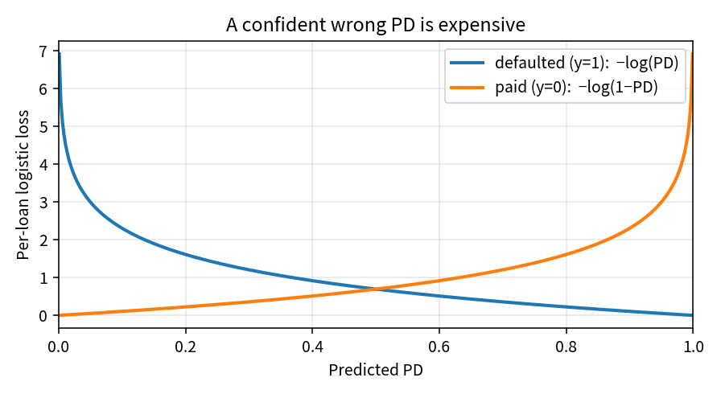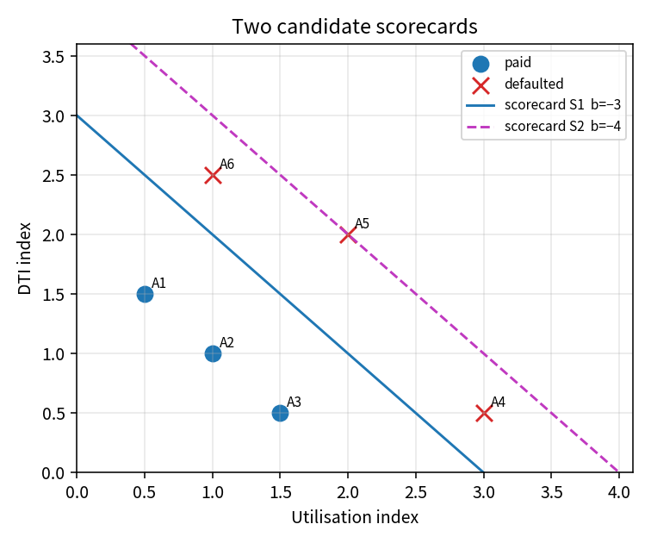
Left: loss vs PD. Right: S1 vs S2 — cheaper J matches the better cut.
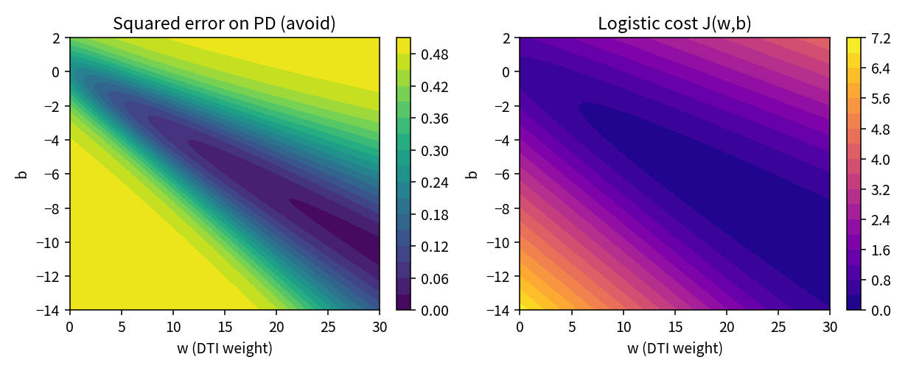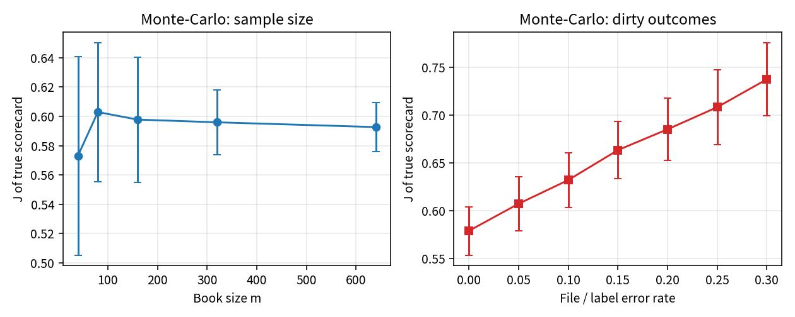
Left: MSE-on-PD vs logistic J. Right: J settles with book size and rises with misfiled outcomes.

Key Takeaways
- Train and rank PD models with logistic / BCE loss, not squared error.
- J is mean surprise on the book. Lower J = scorecard better matches observed defaults.
- Clip PD. One PD of 0 or 1 poisons a whole batch.
- Do not call J a provision. Quote ECL = PD × LGD × EAD to finance.
- Committee hears “0.37 vs 0.50”. Validation hears clip, convexity, and ∇J next.

